Multi-Purpose Room – Te’Ti’Sen
Rates: $25 per hour (2 hour minimum) or $200 per day
We have a 1,689 sf space available to rent to the public. Ideal space to have wedding dinners, family dinners, private meetings, birthday parties, baby showers etc. Maximum capacity for the room is 125.
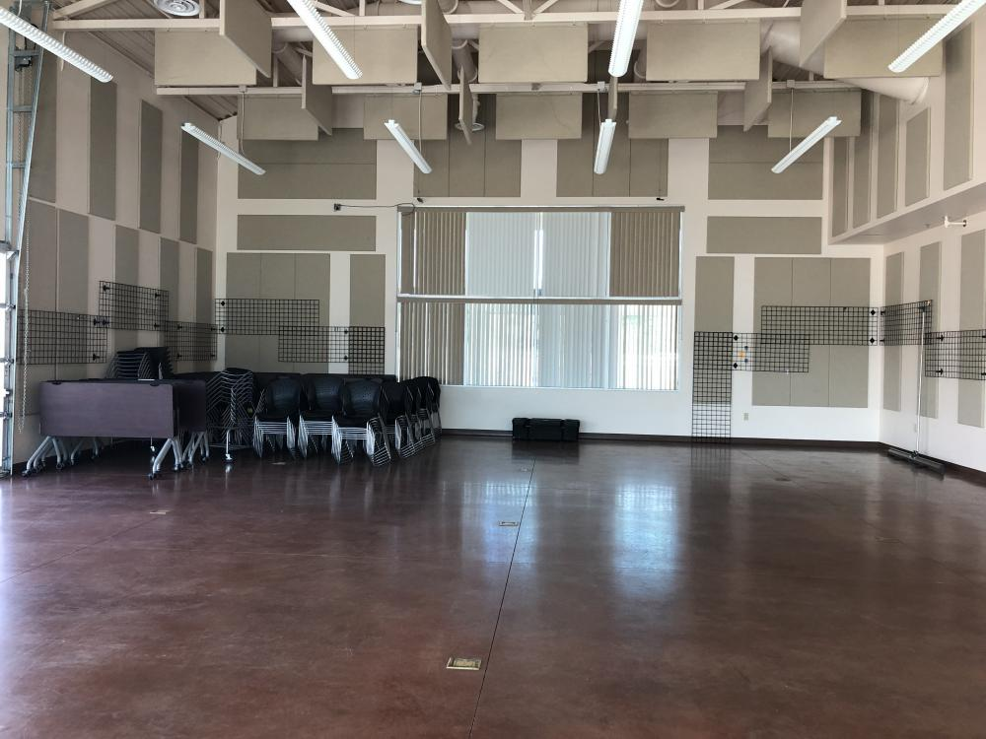Inside the Multi-Purpose Room
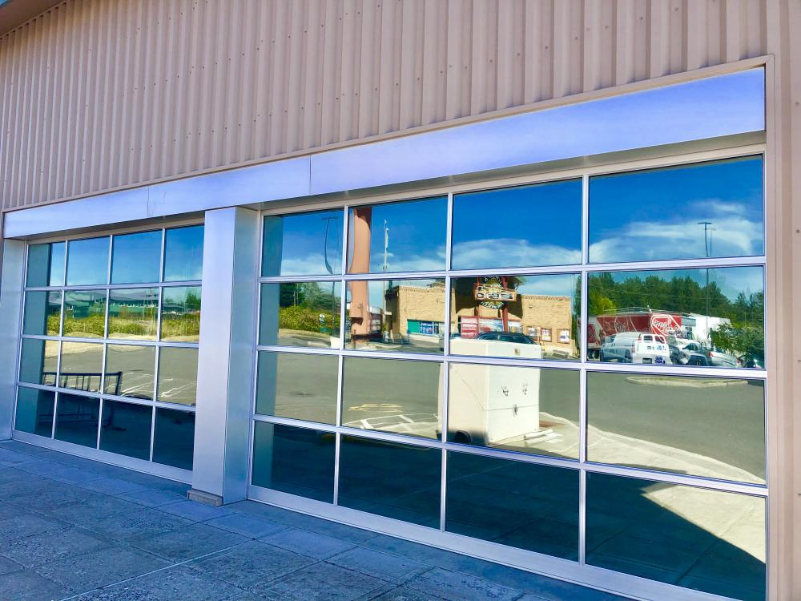Drop Down Doors to the Multi-Purpose Room
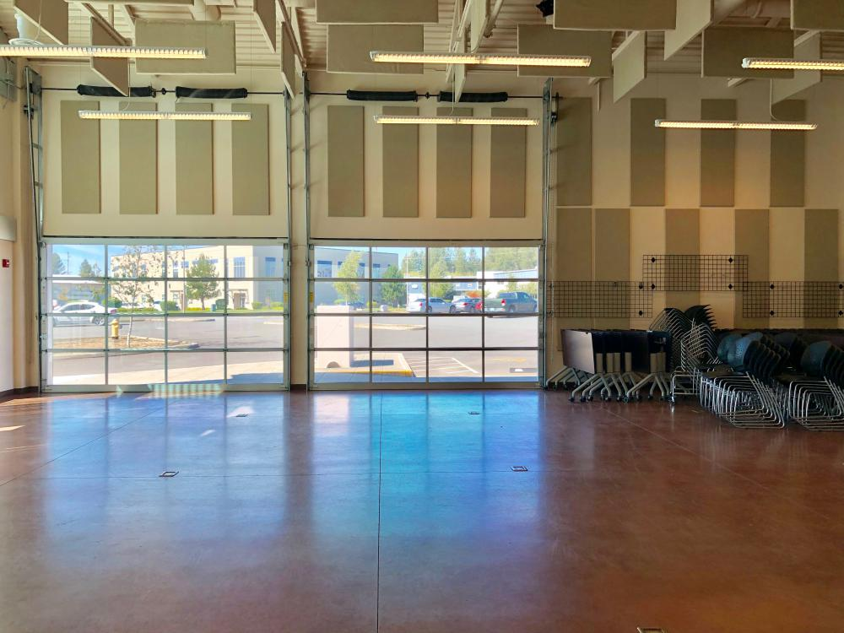Inside MPR View
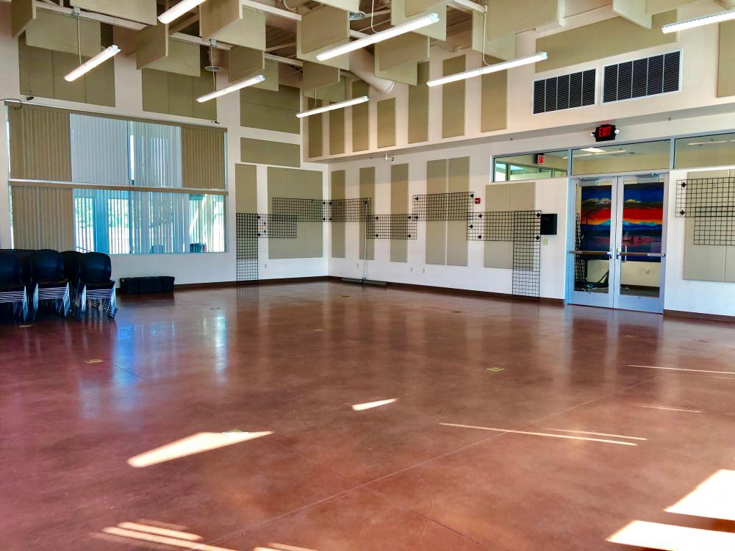Another Angle of Inside MPR
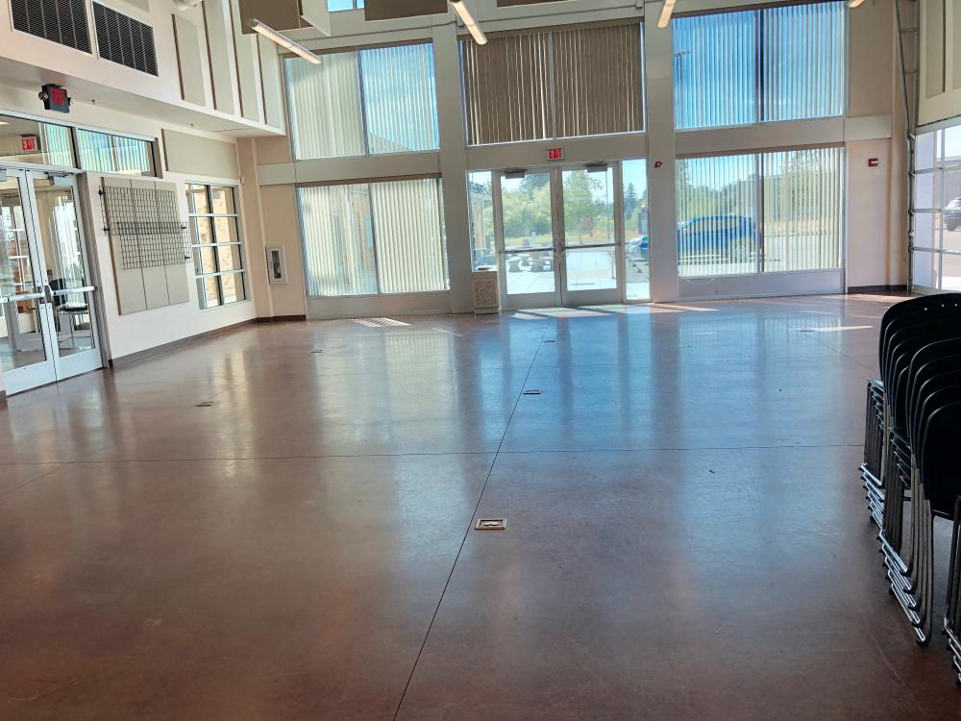

Reserving the Multi-Purpose Room
Contact: Name, Number, Email

